# **CIS 36A :: Lab 01 - Java Fundamentals**

#### **Student Name:**

### **Task 1: Definitions & Concepts**

**Instructions:** Answer the questions below in one sentence.

1. Explain the difference between source code and object code.  
   => Source code is typically what the human writes themselves, while object code is what comes out after compiling.
2. What is Java ***bytecode*** and how does it differ from ***machine code***?  
   => Machine code is binary and directly interpretable by machines, whereas Java byte code is non runnable and needs an interpreter to convert it into machine code.
3. Write three reasons why you should learn Java?  
   => Java has a lot of the fundamentals of most other object oriented programming language so it’s highly applicable elsewhere.  
   Java itself is used in a very large amount of applications, making it a useful language to know.

Java is also easy to learn and has massive amounts of documentation for all levels of expertise.

### **Task 2: Understanding Programming**

Instructions: Answer each question below. Try to understand and explain the code. You do not need to test any code with an IDE. **Do not put an IDE code screenshot.**

1. **Exercise 26:** Use **indentation**, **spacing**, and **multiple lines** to make the following program more readable.

| /* This program computes and prints the sum of the first 10 positive integers */ class SumFrom1To10{public static void main(String[] args){int sum,i;sum=0;for(i=1;i<=10;i++)sum=sum+i;System.out.println("The sum 1+2+...+10 is "+sum);}} |
| --- |

1. **Exercise 27:** Suggest more appropriate names for the class and the variables in the following program.   
   Color your chances.

| /* This program converts Fahrenheit to Celsius. */ class converter {  public static void main(String[] args) {  double x, xx;  x = 62;  xx = (x-32) * 5.0/9.0;  System.out.print(x + " degrees Fahrenheit is ");  System.out.println(xx + " degrees Celsius.");  } } |
| --- |

1. **Exercise 28:** Assume **x** is a variable that is declared as type **int**. What is wrong with each of the following statements?  
   A. x = 3.5; => 3.5 is a double or a float data type but is it’s a integer value being assigned to them.   
   B. if(x = 3)   
    x = 4; => if(x = 3) is wrong. X = 3 is assigning 3 to x instead of comparing. The correct syntax is ==.  
   C. x = "34"; => “34” is a string data type, not an integer.

### **Task 3: Programming Exercises**

Instructions: Use any IDE to write and execute below exercises from the book. Attach Snipping photos of your **source code** and t**est run of the code in the console**. Make sure to create separate files for each exercise.

**Sample Screenshot that shows both your code and output with command line  
[REMOVE THIS BEFORE SUBMISSION]**

**Chapter 1 Exercises (Page 39-41)**

1. **TRY THIS 1-2 - GalToLit**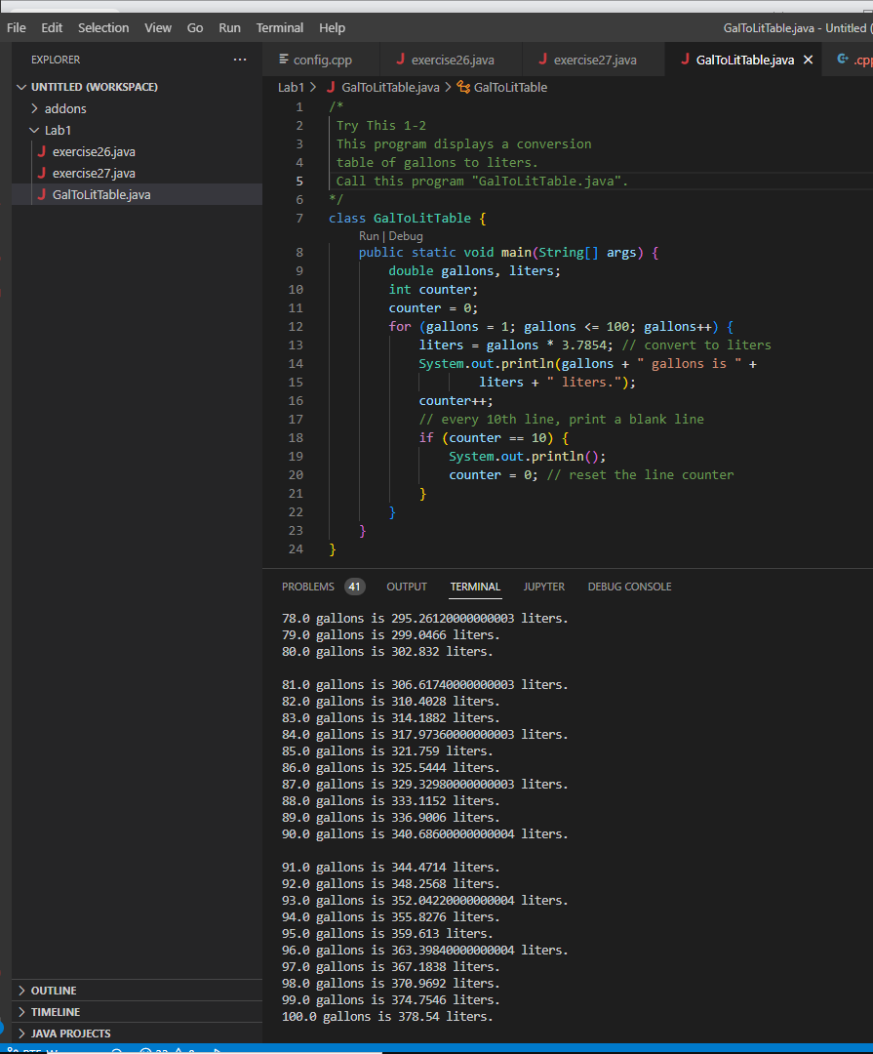
2. **Use System.out.println() to write a program that prints a shape or a face, or a simple picture.** 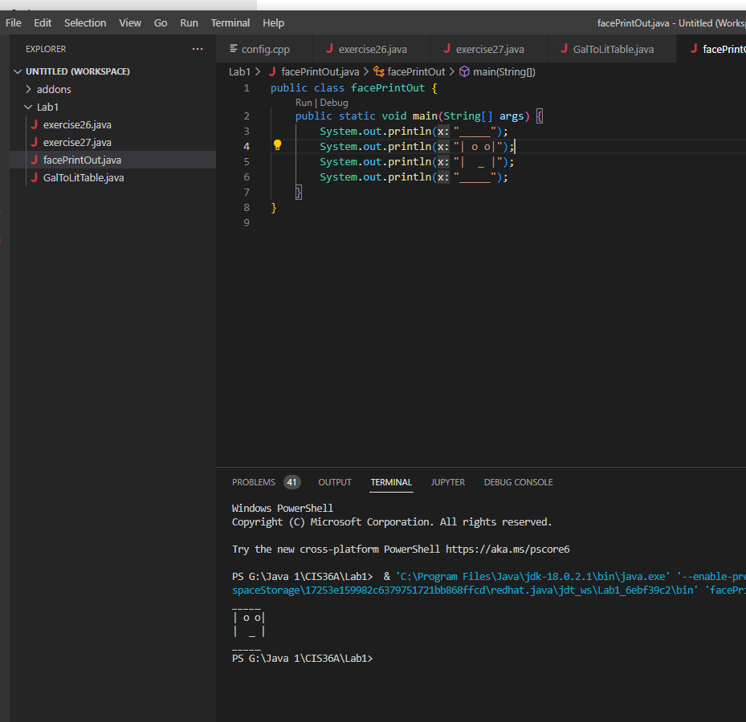
3. **Rewrite the GalToLit program so that it takes gallons as user input and prints out the litters.** 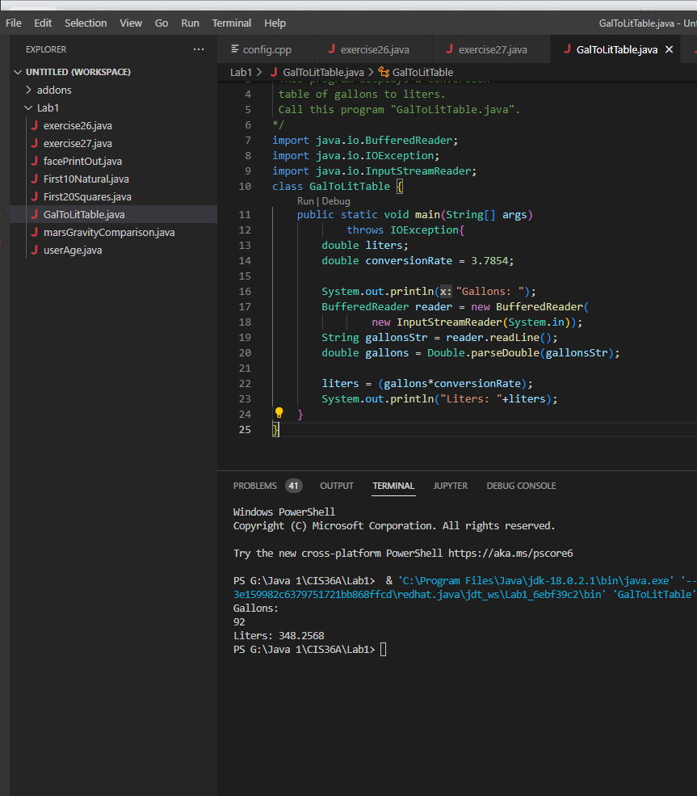
4. **Mars**’s gravity is about 37 percent of earth’s. Write a program that computes and prints your effective weight on Mars.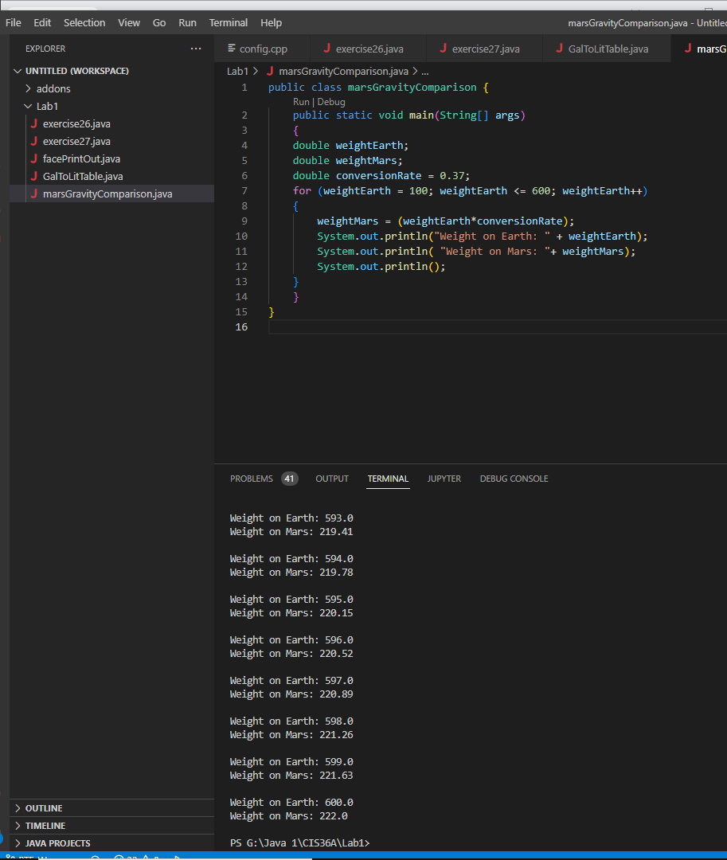
5. Write a program that takes the user's age as an integer (user’s age can be input) and print if they can vote (You must be 18 years old to vote).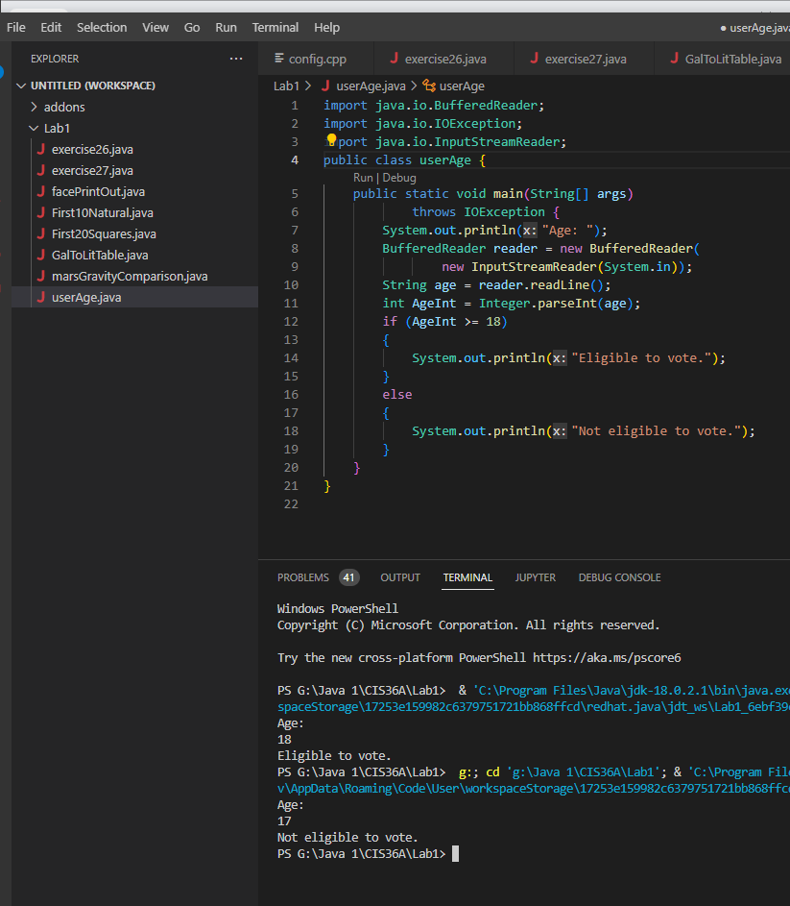
6. Write a program that prints out the first 20 squares (1, 4, 9, 16,..., 400), one per line.   
   Use a for loop.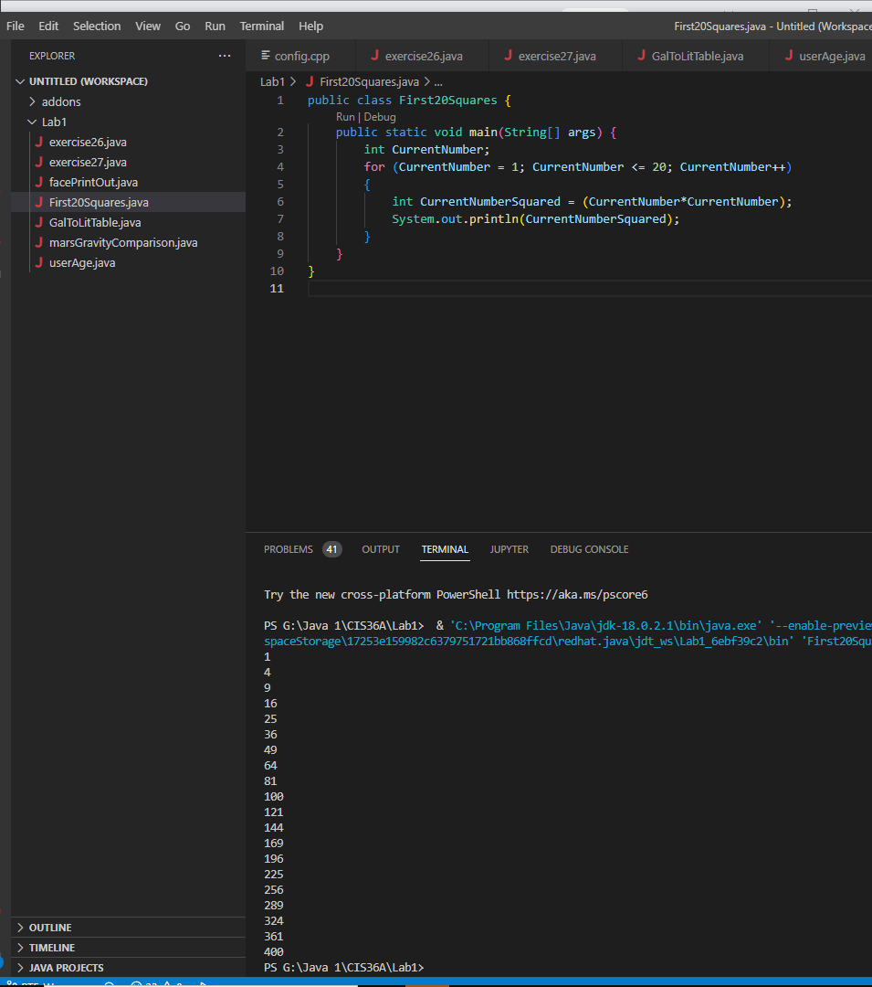
7. Write a program that prints the sum of the first 10 natural numbers (1 + 2 + 3 + ... + 10).   
   Use an accumulator variable, **sum**, and a loop.